LLM Reasoning

chain of thoughts (COT) prompting:
prompt the llm to think in intermediate steps instead of direct answering the question.
This can be achieved by giving examples to llm and later give a new question to llm so llm answers in the same as example! Which result in better performance….

Later instead of giving examples to llm for reasoning…. We can add phrase “lets think step by step” which provided COT to llm. This is known as zero shot COT
still llm did make a lot of mistakes in logical and reasoning problem solving.

Methods to improve COT – pal: program aided language model and ReAct

1. pal: program aided language model

llm + code interpreter

llm generate code as intermediate reasoning steps
input (with in context examples)
where example questions is given with solution in python with proper comments in natural language processing to llm so that llm can learn and later answer in the same way.

2. ReAct:

COT + tools, uses tools to solve the problems

3 stages ( reason + act)
1. thoughts
2. action
3. observation

so what is tools ? Tool → something to perform an action, tools = plugins (function/api calls)

so this tools have 3 types:

1. knowledge access
2. computation
3. interaction with external world

------------------------------------------------------------------------------------------------------------------------

ReAct

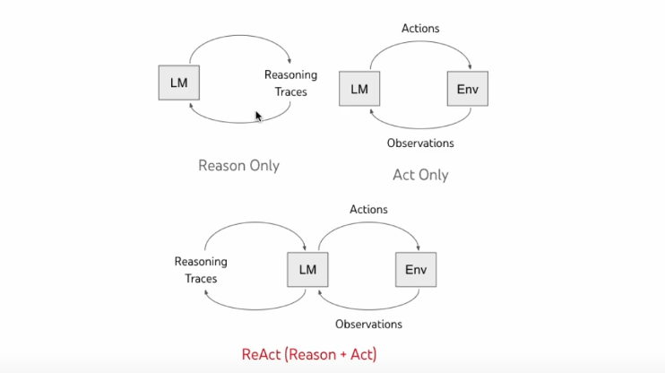
reason only – COT (which basically increases the performace)

act only – about using actions on environment to basically help a llm

